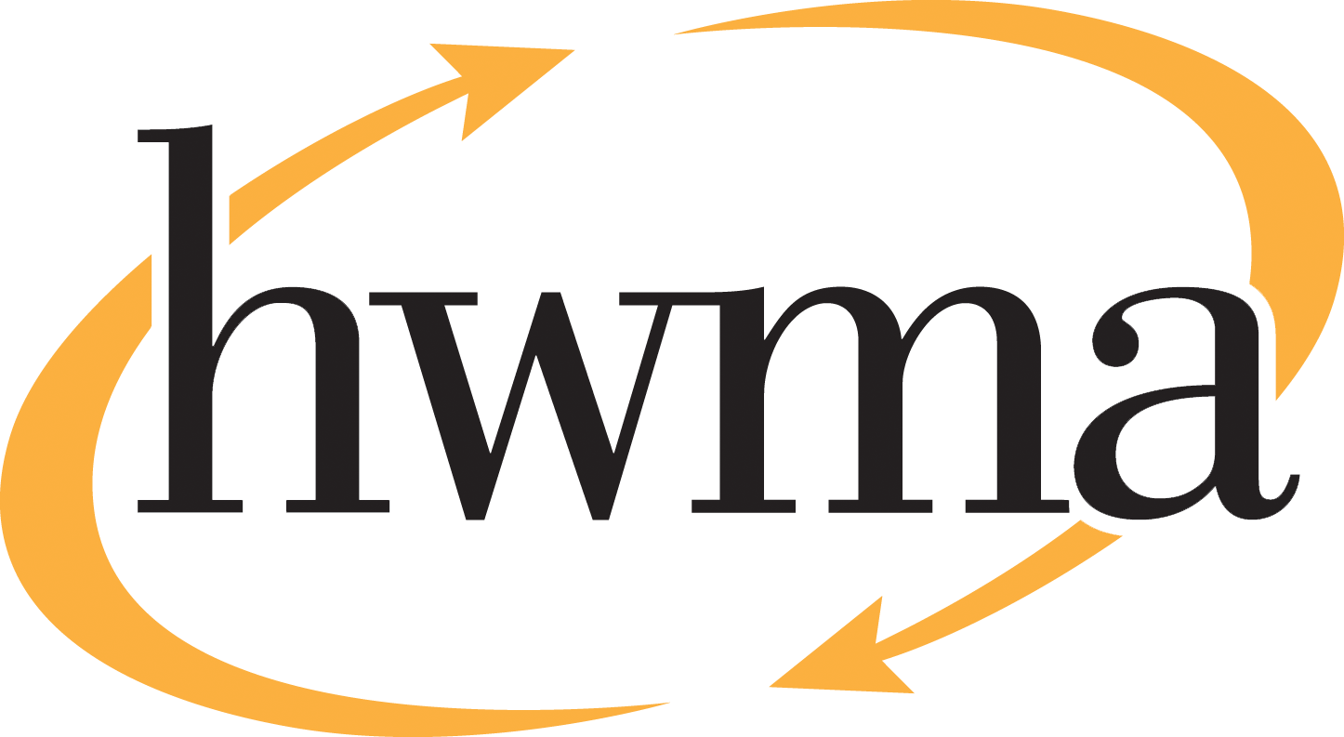
BOARD OF DIRECTORS
Stacy Atkins-Salazar, City of Arcata, Chair
Michelle Lewis-Lusso, City of Blue Lake, Vice Chair
Leslie Castellano, City of Eureka
Randall Cady, City of Ferndale
Steve Madrone, County of Humboldt
Frank Wilson, City of Rio Dell

Minutes
Thursday, August 13, 2026, at 5:30 PM
Eureka City Council Chamber

Present: Stacy Atkins-Salazar, Michelle Lewis-Lusso, Leslie Castellano, Randall Cady, Frank Wilson.
Absent: Steve Madrone
Staff: Eric Keller-Heckman, Helder Morais, Hilary Schwartz
Legal Counsel: Nancy Diamond

- Call to Order and Roll Call at 5:30 PM

Chairperson Atkins-Salazar called the meeting to order at 5:30 PM. A quorum was present and acting.

- Consent Calendar
  - Approve Minutes from the July 9, 2026, HWMA Board of Directors Meeting
  - Review and Approve Draft May 2026 Financial Reports
Chairperson Atkins-Salazar inquired if there were any requests to pull items from the Consent Calendar, and there were no requests.

Chairperson Atkins-Salazar opened the floor to public comment on the Consent Calendar, and no public comment was received.

Chairperson Atkins-Salazar closed the floor to public comment.

Motion: Director Castellano motioned, and Director Cady seconded, to approve items a) through b) of the Consent Calendar as delivered
Action: Approve the Motion as made by Director Castellano and seconded by Director Cady
Ayes: Unanimous
Noes: None
Absent: Director Madrone
- Oral and Written Communications

Chairperson Atkins-Salazar opened the floor to public comment, and no public comment was received.
Chairperson Atkins-Salazar closed the floor to public comment.
- Review and Approve Revisions to HWMA Policy 3030 – Reserve Policy, and Adopt Resolution 2027–04, “A Resolution of the HWMA Board of Directors Adopting Revised HWMA Handbook Policy 3030 – Reserve Policy.”

Director Schwartz presented proposed changes to Policy 3030, the Authority’s Reserve Policy, which incorporate direction received from this board at its regularly scheduled meetings on June 11th and July 9th, 2026. Director Schwartz reviewed the recommendation from the Authority’s independent auditors to propose updated reserve policies that clearly define each of the Authority’s reserves and how they are determined and classified for accounting purposes.

Staff recommendations that remain unchanged since the last proposed revision include the following:

- Revise the Authority’s reserve fund classifications, for financial accounting purposes, to “assigned” and “unassigned” to align with GASB Statement Number 54;
- Adopt the revised methodology for determining the funding level of the Operating Reserve and the approved intended uses for the Long-Term Organics Fund, both of which were discussed and approved at the June 11, 2026, regular meeting.

After incorporating direction from this board received at the July 9, 2026, regular meeting, staff now proposes additional language, denoted 3030.12, which states:

“The classification of fund balances under GASB Statement Number 54 is for accounting purposes only and does not alter the Authority’s delegated spending or budgetary approval authorities. The HWMA Board of Directors retains the sole authority to establish, modify, or eliminate reserves through board action.”

Director Castellano thanked staff for including the additional language and expressed support for the revised policy. There were no further comments or questions from directors.

Chairperson Atkins-Salazar opened the floor to public comment on the Reserve Policy agenda item. No public comment was received.
Motion: Director Cady motioned, and Director Lewis-Lusso seconded, to approve the revisions to Policy 3030 and adopt Resolution 2027–04, “A Resolution of HWMA Board of Directors, Adopting Revised HWMA Handbook Policy 3030–Reserve Policy.”
Action: Approve the Motion as made by Director Cady and seconded by Director Lewis-Lusso
Ayes: Unanimous
Noes: None
Absent: Director Madrone
- Review and Approve Revisions to HWMA Policy 3020.3, and Adopt Resolution 2027–05, “A Resolution of the HWMA Board of Directors Adopting Revised HWMA Handbook Policy 3020.3.”

Director Schwartz provided background on Series 3000 of the HWMA Policy Handbook, which defines the Authority’s financial policies and has been revised several times, including in September of 2025 when the capitalization threshold was increased. In their Management Letter dated February 5, 2026, Authority’s independent auditors recommended that staff propose a revised policy that defines the estimated useful life for depreciation and disposal of capital assets, which ensures consistent treatment of asset depreciation and board approval for disposal of surplus assets. Staff determined that current HWMA Policy 4090.1, which requires that assets be declared surplus by the board, meets the criteria of the auditor’s recommendation and no policy revision is recommended at this time.

Staff is recommending that Policy 3020.3 be revised to specify the use of straight-line method depreciation and the schedule of estimated useful lives of assets that was included in the Authority’s Fiscal Year 2024–25 audited financial statements. The adoption of a useful life schedule will also enhance long-term capital improvement planning to ensure timely replacement of capital assets. These proposed revisions are consistent with the methodologies currently utilized for depreciation and useful life determinations. However, the auditors’ ability to verify the fair presentation of the Authority’s financial statements is improved when they can match financial policies with accounting procedures.

Director Castellano inquired if the asset listed as the “Hawthorne Street Transfer Station” in the schedule of useful lives referred to the Transfer Station buildings. Director Schwartz confirmed that it did refer to buildings as well as building improvements. Director Lewis-Lusso inquired if the equipment category included vehicles, and Director Schwartz confirmed that it did include vehicles, which are typically depreciated over five years.

Chairperson Atkins-Salazar opened the floor to public comment on Policy 3020.3 agenda item. No public comment was received.

Chairperson Atkins-Salazar closed the floor to public comment.
Motion: Director Castellano motioned, and Director Wilson seconded, to approve the proposed revisions to Policy 3020.3 and adopt Resolution 2027–05, “A Resolution of HWMA Board of Directors, Adopting Revised HWMA Handbook Policy 3020.3.”
Action: Approve the Motion as made by Director Castellano and seconded by Director Wilson
Ayes: Unanimous
Noes: None
Absent: Director Madrone
- Receive Presentation on Tire Recycling Program
Director Morais gave a presentation on the HWMA’s Tire Recycling Program, which began in 2017 with an initial award of $88,000 from CalRecycle. Over the past ten years, the Authority has been awarded over $376,000 in used tire recycling grants and accepted over 728 tons of used tires at the Hawthorne Street Transfer Station at no cost to community members. Director Morais described how customers can utilize the program by bringing up to nine (9) eligible used tires per day to the Transfer Station. Following acceptance, tires are sorted, de-rimmed, and staged for pick-up and transport by tire hauler I-5 Tires. Extracted tire rims are placed in the scrap metal bin for recycling.

Most of the tires accepted at the Transfer Station are transported to a facility in Redding, where they are incinerated to generate power to operate a concrete plant. The remainder of the scrap tires are recycled into crumb rubber, which is used to make playground equipment, truck mats, and a variety of other recycled rubber products.

Director Castellano inquired about the status of the new Fiscal Year 2026–27 tire grant. Director Morais confirmed that the most recent grant cycle has just opened, and the Transfer Station has seen a large uptick in used tires. The tire grant program is well-known in the community and residents often save up their used tires until the next grant cycle begins. Director Castellano inquired if the tire rims generate revenue as scrap metal. Director Morais responded that scrap metal values are low, so the revenue realized from rims is minimal, although removing the heavy rims reduces the cost of transporting the tires. Director Castellano inquired about the eligibility of larger commercial tires. Director Morais responded that the program was open to residents only, although staff does provide information to businesses seeking to obtain tire-hauling services.

Chairperson Atkins-Salazar opened the floor to public comment on the Tire Recycling Program agenda item. No public comment was received.
Chairperson Atkins-Salazar closed the floor to public comment.

- Standing Item: Board Member Reports
Director Cady reported that the City of Ferndale is offering a backyard composting program from July 1 to September 30, 2026. The City is providing three different sizes of compost bins valued at up to $300, and so far, 35 residents have applied for and received compost bins through the program.

Director Castellano reported that the Eureka City Council had a couple of contentious conversations regarding the approval of the annual rate review and schedule of fees for services from Recology, the City’s franchise hauler. She thanked Executive Director Keller-Heckman for attending the meetings and providing the Council with the information they needed to achieve consensus.

- Standing Item: Executive Director’s Report

Executive Director Keller-Heckman reported that he will be visiting Dry Creek Landfill in Oregon in mid-October. Following his trip, Executive Director Keller-Heckman will provide the board with an update on the facility, which is the final destination for the majority of Humboldt County’s municipal solid waste.

Executive Director Keller-Heckman provided the board with a brief update on organic waste acceptance at the Hawthorne Street Transfer Station. The commencement of organics collection in Humboldt County has now shifted from the intended start date of October 1, 2026. Executive Director Keller-Heckman will provide the board with an update on organics acceptance at the regularly scheduled October meeting, as well as an update on the Strategic Vision planning at the September meeting.

- Report Out of Closed Session: It is the intention of the Board of Directors to meet in closed section for one item: Public Employee Performance Evaluation – Executive Director, pursuant to Government Code §54957.

Chairperson Atkins-Salazar opened the floor to public comment regarding closed session. No public comment was received.

Chairperson Atkins-Salazar adjourned the meeting to closed session at 6:06 pm.

Chairperson Atkins-Salazar called the meeting to order from closed session at 7:42 pm.

No Report Out from closed session was required.

- Adjourn

Chairperson Atkins-Salazar adjourned the meeting at 7:42 pm following closed session.

