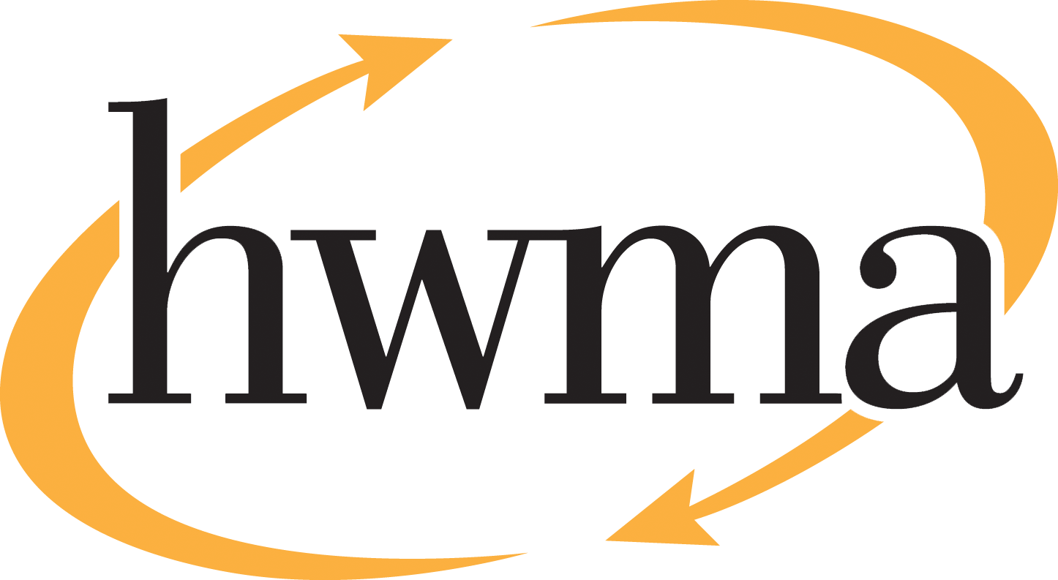
BOARD OF DIRECTORS
Stacy Atkins-Salazar, City of Arcata, Chair
Michelle Lewis-Lusso City of Blue Lake, Vice Chair
Leslie Castellano, City of Eureka
Randall Cady, City of Ferndale
Steve Madrone, County of Humboldt
Frank Wilson, City of Rio Dell
Minutes
Thursday, June 11, 2026, at 5:30 PM
Eureka City Council Chamber

Present: Meredith Matthews (alternate), Michelle Lewis-Lusso, Leslie Castellano, Randall Cady, Steve Madrone, Frank Wilson.
Absent: None
Staff: Eric Keller-Heckman, Tony Heacock, Helder Morais, Hilary Schwartz
Legal Counsel: Nancy Diamond

- Call to Order and Roll Call at 5:30 PM

Chairperson Matthews called the meeting to order at 5:30 PM. A quorum was present and acting.

- Consent Calendar
  - Approve Minutes from the May 14, 2026, HWMA Board of Directors Meeting
  - Review and Approve Draft March 2026 Financial Reports
Chairperson Matthews inquired if there were any requests to pull items from the Consent Calendar, and there were no requests.

Chairperson Matthews opened the floor to public comment on the Consent Calendar, and no public comment on the Consent Calendar was received.

Chairperson Matthews closed the floor to public comment.

Motion: Director Castellano motioned, and Director Cady seconded, to approve items a) through b) of the Consent Calendar as delivered
Action: Approve the Motion as made by Director Castellano and seconded by Director Cady
Ayes: Unanimous
Noes: None
Absent: Director Madrone

- Oral and Written Communications

Chairperson Matthews opened the floor to public comment regarding items not on the agenda. Public comment was received from Mr. Frank Nelson, General Manager of Recology Humboldt County. Mr. Nelson invited board members to visit the Recology Resource Recovery Center in Samoa. Chair Matthews inquired about the Junk Museum, an area where recycled art was displayed at the facility in Samoa. Mr. Nelson advised that the Junk Museum was being converted into an interactive educational space similar to the Discovery Museum.
Chairperson Matthews noted for the minutes that Director Madrone arrived at 5:32pm and closed the floor to public comment.
- Receive presentation on PARS Pension Rate Stabilization Program and Approve Resolution 2026–08 “A Resolution of the Humboldt Waste Management Authority Approving the Adoption of the Public Agencies Post-Employment Benefits Trust Administered by Public Agency Retirement Services (PARS).”

Director Schwartz reported to the board that the HWMA carries a long-term unfunded pension liability with CalPERS. An unfunded liability represents the difference between the pension benefits earned by employees and the assets currently set aside to pay those benefits. As of June 30, 2024, the Authority’s unfunded pension liability is approximately $1.4 million. Over time, unfunded liabilities incur interest and will cause annual contribution rates to rise, putting pressure on the Authority’s operating budget.

A Section 115 Trust is a legally compliant mechanism to set aside funds specifically for pension obligations. This strategy can help stabilize contribution rates over time and increase fiscal sustainability. Key benefits of a Section 115 Trust include cost savings by earning interest, budget stability, and strategic pre-funding of pension obligations with additional discretionary payments (ADPs) to CalPERS. Risks include market volatility and the need to develop policies to complete the governance structure of the trust. If funded, the trust would incur management fees of 0.6% of the fund balance annually.

The board received a presentation from Mr. Matt Spooner of Public Agency Retirement Services (PARS), a private third-party that administers pension rate stabilization trust funds for many public agencies in California. The PARS 115 Trust, called the Pension Rate Stabilization Program (PRSP) is supported by three entities – PARS, the Trust Administrator, PFM Asset Management, the Investment Manager, and US Bank, the Trustee. The PRSP is a pension pre-funding tool that can be invested in the stock market and grow at a faster rate than typical public agency pooled investments.

Mr. Spooner summarized the Authority’s most recent actuarial report and advised that its unfunded liability is growing. He described the PRSP as a pension smoothing tool that always remains under local control. He presented analysis of PARS historical net performance fees and the five different investment strategies available at differing levels of equity exposure. Finally, Mr. Spooner covered fund fees and various funding strategies that have worked for other agencies.

Director Castellano expressed concern about risk exposure and how the board might weigh in on a policy regarding risk exposure. Executive Director Keller-Heckman responded that this was the first time the Authority had taken a close look at its pension liability and that establishing the trust was the first step in a larger process. Staff would be returning to the board with draft policies governing funding strategies, risk exposure, and level of board oversight for the trust, should the board choose to approve it. Director Castellano asked about market risks, and if and how the Authority would remove its funds from the trust if pension obligations were otherwise resolved. Mr. Spooner advised that market risks could be limited to about 5% exposure in the most conservative investment strategy. He emphasized that agencies enjoy total local control over their funds and can withdraw them at any time.

Director Castellano inquired about the experiences of other jurisdictions represented on the board who had established PARS trusts. Chairperson Matthews reported that the City of Arcata had established a PARS trust about a year ago and had good results. She expressed support for the PARS trust as a strategic financial move for public agencies. Director Madrone indicated that he did not have any specific knowledge of the County’s involvement with PARS but expressed his personal preference against investing in the stock market. He acknowledged the significance of unfunded liabilities and that staff was recommending the Authority establish the PARS trust, without the need for a current funding commitment. Director Wilson expressed concern about investing in the stock market, but recommended the Authority establish the trust and take a moderate to moderately conservative investment approach. Director Lewis-Lusso expressed support for the trust as a good start toward segregating funds for pension obligations.

Chairperson Matthews opened the floor to public comment on the PARS trust agenda item. No public comment was received.
Motion: Director Castellano motioned, and Director Cady seconded, to approve Resolution 2026–08 “A Resolution of the Humboldt Waste Management Authority Approving the Adoption of the Public Agencies Post-Employment Benefits Trust Administered by Public Agency Retirement Services (PARS).”
Action: Approve the Motion as made by Director Castellano and seconded by Director Cady
Ayes: Unanimous
Noes: None
Absent: None

- Approve the Annual Recycling Processing Fee and Adopt Resolution 2027–02 for the Collection of Integrated Waste Management Fees.

Executive Director Keller-Heckman provided the board with background information on processing and marketing of curbside and collected recyclables in Humboldt County, which was a piecemeal process for many years. In 2018, the jurisdictions and HWMA executed a Memorandum of Understanding (MOU) granting HWMA flow control over recyclable materials with the hope of securing better processing and marketing rates for local materials. The Authority issued a Request for Proposals for recycling processing and marketing services, and Recology Humboldt County was the successful proposer. Since 2018, Recology Humboldt County has processed and marketed the jurisdiction’s recyclable materials at their facility in Samoa.
The fee for recycled materials is adjusted annually and can take longer to determine than other fees, because a portion of the recycling fee is determined by the Authority’s own annually adjusted solid waste tipping fee. Residuals, the portion of recyclable materials that either can’t be marketed or is contaminated, are returned to the solid waste transfer station and incur tipping fees. Once HWMA staff finalized the Authority’s tipping fees, they began working with Recology staff to finalize the recycling fee.

Executive Director Keller-Heckman advised the board that Section 4 of Resolution 2027–02 would be changed upon the advice of General Counsel Diamond to state the following: “Resolution 2027–01, a Resolution of the Humboldt Waste Management Authority for the Amendment of Integrated Waste Management Fees, is hereby amended by the adoption of Table 9, the Recyclable Materials Processing Fee, attached in Schedule A. Said Table 9 is hereby incorporated into the original schedule of Resolution 2027–01, and shall take effect July 1, 2026.”

Director Castellano inquired about the drivers behind the 15% increase in the recycling fee. Executive Director Keller-Heckman responded that the three biggest issues driving the rate increase are transportation, labor, and the largest factor, the reduction in recyclable tons collected. In prior years, the high residual rate was problematic, but while still too high, the residual rate decreased slightly this year. The reduction in recyclable tons could be related to decreased economic activity, reduced producer packaging, and the rise of CRV centers in Humboldt County. CRV materials are usually the highest value materials in the waste stream.

Mr. Frank Nelson, General Manager of Recology Humboldt County, described to the board that the Recology Resource Recovery Center processes and markets recyclable materials from a wide region of Northern California and Southern Oregon. The cost per ton to process materials increases when the number of tons collected decreases. Recology reduced labor by over 3,000 hours in an effort to control costs per ton. Mr. Nelson concurred with Executive Director Keller-Heckman’s analysis that economic conditions have reduced consumption, but that simultaneously, recycling services are proliferating and expanding into new areas. Director Madrone commented that over time, many plastic materials became unrecyclable locally. Mr. Nelson advised that Recology is one of the first organizations on the North Coast working with the Circular Action Alliance and CalRecycle on plastics recycling in alignment with SB 54, the Plastic Pollution Prevention and Packaging Producer Responsibility Act, legislation that will shift what plastics are recoverable and who is paying for it.

Chairperson Matthews opened the floor to public comment on the annual recycling processing fee agenda item. No public comment was received.

Chairperson Matthews closed the floor to public comment.
Motion: Director Castellano motioned, and Director Lewis-Lusso seconded, to approve Resolution 2027–02, a Resolution of the Humboldt Waste Management Authority for the Amendment of Waste Management Fees, as revised by staff’s recommendation
Action: Approve the Motion as made by Director Castellano and seconded by Director Lewis-Lusso
Ayes: Unanimous
Noes: None
Absent: None
- Operating Reserve Discussion

Director Schwartz reviewed the Management Letter provided by Richardson & Company, LLP, the Authority’s auditors, which included a recommendation to develop reserve policies that clearly define each of the Authority’s reserves and how their funding levels are determined. Staff will return to the board with a comprehensive update to HWMA Policy 3030, Reserves, prior to the next audit cycle in accordance with the auditor’s recommendations.

Staff requests direction on the following items pertaining to the Authority’s reserves:

- Confirmation of the currently approved intended uses of the Operating Reserve.
- Revision of the methodology used to determine the funding level of the Operating Reserve to 15% of the operating budget, less the fully funded Rate Stabilization and Personnel Stabilization Reserve account balances.
- Identification of long-term organics processing as the intended use of the Long-Term Funding and renaming it the Long-Term Organics Fund.
Staff recommends the board discuss and provide direction on these items and direct staff to return with a comprehensive update to Policy 3030, incorporating proposed language no later than July 9, 2026.

Director Castellano expressed support for reserves and inquired how it would affect the Authority’s budget and financial planning to increase the funds in the Operating Reserve to the level determined using the revised methodology. Director Schwartz responded that during each budget cycle, staff identifies the funding needed by each of the Authority’s reserve accounts in the coming fiscal year and builds the funding into the annual fee table. For example, the Long-Term Funding is a line item in the Base Fees, while the Capital Improvement Funding is a line item in the Facility Fee. Increases to the Operating Reserve would likely be split over two fiscal years to smooth the impact to rate payers.

Director Castellano inquired as to how the Authority could change directions if it determined that the Long-Term Funding was no longer needed for organics processing. Executive Director Keller-Heckman responded that nothing would preclude the board from reallocating the funds to a different purpose, but that he would not recommend placing a threshold or a timeline in the reserve policy.
Chairperson Matthews opened the floor to public comment on the Operating Reserve agenda item. No public comment was received.

Chairperson Matthews closed the floor to public comment.

The board directed staff to return with a comprehensive update to Policy 3030 no later than the July 9, 2026, meeting.
- Standing Item: Board Member Reports. No reports received.

- Standing Item: Executive Director’s Report
No reports received.

- Closed session: It is the intention of the Board of Directors to meet in closed session for two items:

  - Closed session pursuant to Government Code 54956.8 Real Property to consider the potential price and terms of purchase of APN 405-081-036.

  - Public Employment Evaluation – Executive Director pursuant to Government Code Section 54957.

Chairperson Matthews opened the floor to public comment on the Closed Session agenda item. No public comment was received.

Chairperson Matthews closed the floor to public comment.

- Report Out of Closed Session: No report.

Chairperson Matthews adjourned the Closed Session at 7:05 pm.

