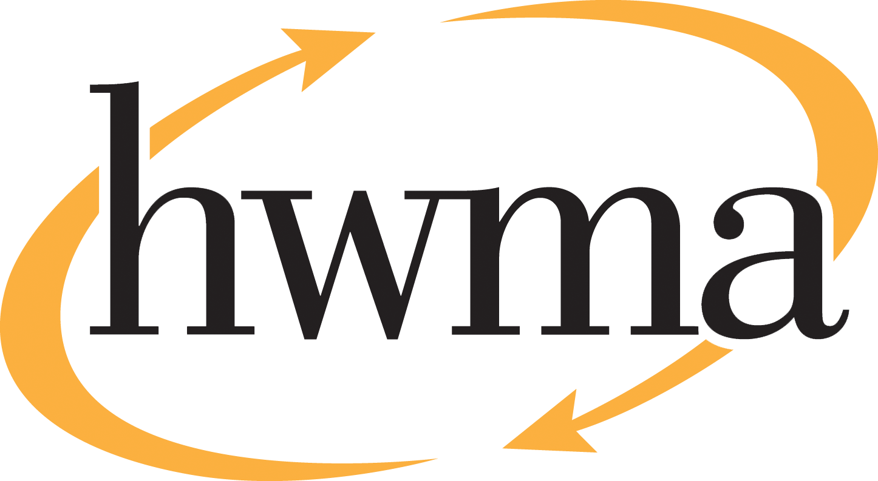
BOARD OF DIRECTORS
Stacy Atkins-Salazar, City of Arcata, Chair
Michelle Lewis-Lusso City of Blue Lake, Vice Chair
Leslie Castellano, City of Eureka
Randall Cady, City of Ferndale
Steve Madrone, County of Humboldt
Frank Wilson, City of Rio Dell
Minutes
Thursday, May 14, 2026, at 5:30 PM
Eureka City Council Chamber

Present: Stacy Atkins-Salazar, Michelle Lewis-Lusso, Leslie Castellano, Randall Cady, Steve Madrone, Frank Wilson.
Absent: None
Staff: Eric Keller-Heckman, Helder Morais, Hilary Schwartz
Legal Counsel: Nancy Diamond

- Call to Order and Roll Call at 5:30 PM

Chairperson Atkins-Salazar called the meeting to order at 5:30 PM. A quorum was present and acting. Director Madrone joined the meeting at 5:50 pm, attending remotely with cause (childcare).

- Consent Calendar
  - Approve Minutes from the April 9, 2026, HWMA Board of Directors Meeting
  - Review and Approve Draft February 2026 Financial Reports
  - Authorize Executive Director to Execute an Amendment to the Mattress Recycling Services Agreement
  - Award Bid for Hawthorne Street Facility Organics Scale
Chairperson Atkins-Salazar inquired if there were any requests to pull items from the Consent Calendar, and there were no requests.

Chairperson Atkins-Salazar opened the floor to public comment on the Consent Calendar, and no public comment on the Consent Calendar was received.

Chairperson Atkins-Salazar closed the floor to public comment.

Motion: Director Cady motioned, and Director Castellano seconded, to approve items a) through d) of the Consent Calendar as delivered
Action: Approve the Motion as made by Director Cady and seconded by Director Castellano
Ayes: Unanimous
Noes: None
Absent: Director Madrone

- Oral and Written Communications

Chairperson Atkins-Salazar opened the floor to public comment regarding items not on the agenda. No public comment was received.
Chairperson Atkins-Salazar closed the floor to public comment.
- Receive presentation on PARS Pension Rate Stabilization Program.

Executive Director Keller-Heckman requested that Agenda Item # 4 be pulled due to issues with the resolution language and that the board direct staff to return with the item at the June regular meeting.

- Receive and Approve Fiscal Year 2026–27 Budget

Executive Director Keller-Heckman presented the board with an overview of the Authority’s Fiscal Year 2026–27 budget process. The budget timeline began with the initial presentation of the draft budget to the board on April 9, 2026, after which the draft was provided to jurisdiction staff. HWMA staff met with jurisdiction staff and discussed and answered any questions they had about the budget. Jurisdiction staff had no recommended changes to the budget as presented. Following adoption by the HWMA Board on May 14, 2026, staff will circulate the final budget, resolution, and fee schedule to member agencies and franchise haulers with an effective date of July 1, 2026.

The Authority’s budget assumptions remain largely unchanged from the draft to the final version. Executive Director Keller-Heckman advised the board that the presentation of the final budget would focus primarily on changes that have occurred since the draft.

- Revenue assumptions remain unchanged and are based on a projected 83,000 tons of member agency solid waste and approved grant funding. Total projected revenue is $17,129,546, a slight decrease from the prior fiscal year.
- Expenditure assumptions have been solidified by using actual CPI adjustments for applicable contracts and finalized insurance adjustment amounts. The final budget proposes a COLA of 2.7% for all staff, and implementation of all identified capital projects. Total projected expenditures are $17,129,546, a slight decrease from the prior fiscal year.
- The final budget proposes a new methodology for treated wood waste fees.
- Backhauls have continue to decline and are projected at a rate of 10% for FY 26–27. Staff will continue to monitor this issue and update the board as needed.
- Summary of Projected Revenues:
  - Countywide & Base Fees – $44,486, 270 (Line 12)
  - Solid Waste Tip Fees – $10,014,975 (Lines 14–19, 23)
  - Greenwaste Tip Fees – $206,700 (Lines 21–22)
  - Other Income & Grants – $2,421,601 (Line 28, 38)
Gross Projected Revenue – $17,129,546 (Line 39)
- Summary of Projected Expenditures:
  - Transportation & Disposal – $6,890,143 (Line 93)
  - CWPF Pass-throughs – $1,047,577 (Line 104)
  - Payroll Expenses – $3,379,595 (Line 114)
  - Direct/Indirect Operating – $2,466,354 (Lines 41–85)
  - Reserve Funding – $881,676 (Lines 116, 118)
  - Grants & Other Expenses – $2,464,201 (Lines 119–126)
Total Projected Expenditures – $17,129,546
- With these projected revenues and expenditures, the Authority maintains a balanced budget with zero projected net income.
- Summary of proposed rate adjustments (per ton), now finalized:
  - Self-Haul: $216.47 (3.83% increase)
  - Franchise: $194.08 (3.55% increase)
  - Recology Eel River Satellite Fee: $157.33 (1.25% decrease)
  - Humboldt Sanitation Satellite Fee: $154.43 (1.66% decrease)
  - Countywide Program Fee: $24.20 (5.57% decrease)
  - Greenwaste: $161.47 (2% increase)
  - Recyclable Materials: To be determined following staff review
- Three of the Authority’s four reserve funds are fully funded for FY 26–27, with the Capital Improvement Fund requiring an increase of $881,676 to meet funding requirements. Staff is analyzing the Authority’s reserve policy and funding levels and will return to the board with recommendations as needed prior to the FY 27–28 budget cycle.
- The methodology used to propose the 2.7% Cost-of-Living adjustment for Authority staff was approved by this board in FY 24–25. The final budget proposes unfreezing all currently frozen Materials Diversion Technician (MDT) positions prior to the start of the Organics operation.
- The final budget proposes a charge to $96.00 per ton, plus the solid waste fee, for treated wood waste disposal.
  - Prior to 2020, treated wood waste was handled the same way as all other municipal solid waste and required no additional disposal costs or fees. In early 2020, the State of California passed legislation that classified treated wood waste as hazardous waste.
  - In August 2021, the passage of AB 332 created alternative handling methods and procedures, which allowed transfer stations to resume acceptance of treated wood waste, with additional handling and disposal requirements.
  - Staff initially implemented a per trip fee, in addition to the solid waste fee, for treated wood waste disposal, until more data could be collected about the overall costs, revenues, and tonnage received.
  - This year staff proposes a fee of $96.00 per ton, applied to actual tonnage received, which represents the additive cost of the handling and disposal requirements placed on treated wood waste.
  - The new fee structure recovers all costs while improving accuracy and continuity of charges.
- The final FY 26–27 Capital Improvement Plan proposes three new projects:
  - 2029:04: Solid Waste Scales 1 & 2 Replacement
  - 2033.02: Paving Trailer Staging Area
  - 2033.03: Landfill Roof Replacement & Solar Panels

- The HWMA Organics Processing Facility is expected to come online in October 2026, representing a significant shift in the way the Authority handles revenues and expenditures related to greenwaste and food waste. In the coming months, staff will bring forward a brand-new facility fee structure that will replace the current greenwaste fee when the new facility comes online.

Director Castellano inquired about the new minimum fee for solid waste self-haul customers. Executive Director Keller-Heckman replied that the new minimum fee would be $13.00, an increase of $0.50 from the current minimum fee of $12.50. Director Castellano inquired about the increased insurance costs in the final budget. Executive Director Keller-Heckman advised that staff had originally projected an increase of 10% for insurance costs in the draft budget, but the actual increase turned out to be about 12%, a smaller increase than some of the other jurisdictions have experienced. Director Castellano asked for more information about declining backhauls. Executive Director Keller-Heckman explained that the reduction in backhauls is due to a lack of material coming into Humboldt County. Traditionally, the incoming materials were wood waste (chips, hog fuel), and soil or soil amendments. Over the last 5 to 7 years, both the wood waste and cannabis industries have declined significantly and current trends do not indicate recovery of previous backhaul rates at this time.

Director Castellano asked about completed projects on the Capital Improvement Plan from prior fiscal years. Executive Director Keller-Heckman responded that completed projects will be removed in the FY 27–28 budget cycle once their funding windows are complete. Section 5 of the Capital Improvement Plan, “Projects to be Removed,” is used to memorialize completed CIP projects. Director Castellano inquired if there would be a benefit to accelerating solar projects in the Capital Improvement Plan. Executive Director Keller-Heckman responded that preparatory work for electrification with agencies such as PG&E and RCEA has begun, and based on the outcome of that work, solar projects may be moved up in the Capital Improvement Plan.

Director Madrone advised that he had joined the meeting and was attending remotely with cause (childcare). Chairperson Atkins-Salazar thanked staff for the forward-thinking theme of the budget presentation. She expressed her support for increasing reserve balances and long-term planning for capital improvement projects.

Chairperson Atkins-Salazar opened the floor to public comment on the draft budget agenda item. No public comment was received.

Chairperson Atkins-Salazar closed the floor to public comment.
Motion: Director Cady motioned, and Director Lewis-Lusso seconded,
to approve the Fiscal Year 2026–27 Budget and Adopt Resolution 2027–01 for the Collection of Integrated Waste Management Fees
Action: Approve the Motion as made by Director Cady and seconded by Director Lewis-Lusso
Ayes: Unanimous
Noes: None
Absent: None
- Set a Special Meeting for the Purpose of Approving the Annual Recycling Processing Fee for Fiscal Year 2026–27.

Executive Director Keller-Heckman noted that the Recycling Processing Fee was absent from the final budget because staff was still working with the member agencies’ franchise hauler, Recology, on the pricing structure for that fee. He requested that the board discuss potential dates for a Special Meeting in late May to approve that item. Other items may be added to the Special Meeting agenda.

Following discussion, the board selected Wednesday, May 27, 2026, at 5:30 pm for a Special Meeting.

Chairperson Atkins-Salazar opened the floor to public comment on the Special Meeting agenda item. No public comment was received.

Chairperson Atkins-Salazar closed the floor to public comment.
Motion: Director Castellano motioned, and Director Lewis-Lusso seconded, to set a Special Meeting for the Purpose of Approving the Annual Recycling Processing Fee for Fiscal Year 2026–27 on May 27, 2026, at 5:30 pm
Action: Approve the Motion as made by Director Castellano and seconded by Director Lewis-Lusso
Ayes: Unanimous
Noes: None
Absent: None
- Approve Resolution 2026-09 “A Resolution of the Humboldt Waste Management Authority to Award a Sole Source Construction Contract to American Restore, Inc. for the Organics Processing Facility Floor Repair and Overlay Project.”
Executive Director Keller-Heckman explained that this project dates back to late 2023, when this board approved the Request for Bids (RFB) for the Organics Processing Facility Floor Repair and Overlay Project. Following the RFB release, the Authority was awarded a $2.7 million grant to cover the costs associated with retrofitting the facility for Organics acceptance, including this project. The floor where Organic material will be accepted, sorted, and loaded requires a highly specialized overlay floor material that is able to withstand the chemical makeup of organic and food waste. The HWMA worked with engineering firm Lawrence & Associates to develop the plan for the floor overlay.

The RFB was released in February 2026, and staff immediately heard from potential proposers that there was a procurement issue with the overlay material. Staff contacted the manufacturer, who confirmed that the material had become extremely limited in availability due to warranty issues related to improper installation. The manufacturer now provides access to the overlay material to just one licensed contractor on the West Coast – American Restore, Inc. – a contractor who previously applied the same specialized coating to the Hawthorne Street Transfer Station’s solid waste tipping floor. American Restore, Inc. has confirmed their ability, willingness, and availability to complete the Organics Processing Facility Floor Repair and Overlay Project for a total cost of $999,878. The costs will be covered by the ORG7 Organics Grant funding. Due to the lack of bids obtained as a result of the unavailability of the required material, notification of limited availability of the required material, and confirmation by the manufacturer of a singular licensed contractor, staff request that the board approve a Sole Source Construction Contract to American Restore, Inc. at the price provided and adopt Resolution 2026-09.
Chairperson Atkins-Salazar opened the floor to public comment on the Sole Source Construction Contract agenda item. No public comment was received.

Chairperson Atkins-Salazar closed the floor to public comment.
Motion: Director Castellano motioned, and Director Lewis-Lusso seconded, to Approve Resolution 2026-09 “A Resolution of the Humboldt Waste Management Authority to Award a Sole Source Construction Contract to American Restore, Inc. for the Organics Processing Facility Floor Repair and Overlay Project” in the amount of $999,878, and authorize the Executive Director to execute a contract with American Restore, Inc. subject to review and approval by HWMA General Counsel.
Action: Approve the Motion as made by Director Castellano and seconded by Director Lewis-Lusso
Ayes: Unanimous
Noes: None
Absent: None
- Standing Item: Board Member Reports

Director Castellano reported that she and a group of others had stenciled eight Recology dumpsters in Eureka’s Opera Alley to help beautify the City’s alleys.

- Standing Item: Executive Director’s Report

Executive Director Keller-Heckman reported that the HWMA had partnered with the City of Eureka and Recology to distribute free compost to the public on Saturday, April 18, 2026, at the Annual Spring Garden Giveaway in Samoa. The event was very well-received and well-attended by the public and jurisdiction staff. Executive Director Keller-Heckman thanked the City of Eureka and Recology for inviting the HWMA to participate.

Executive Director Keller-Heckman also reported that HWMA staff has begun talks with several community composters in concert with City of Eureka and City of Arcata staff. Discussions with businesses such as Full Cycle Compost and the Worm Guy are ongoing to identify how they will fit into the new landscape of organics and food waste collection and processing.

- Closed session: It is the intention of the Board of Directors to meet in closed session for one item:

  - Public Employment Evaluation – Executive Director pursuant to Government Code Section 54957.

- Report Out of Closed Session: No report.

Chairperson Atkins-Salazar adjourned the Closed Session at 7:48 pm.

