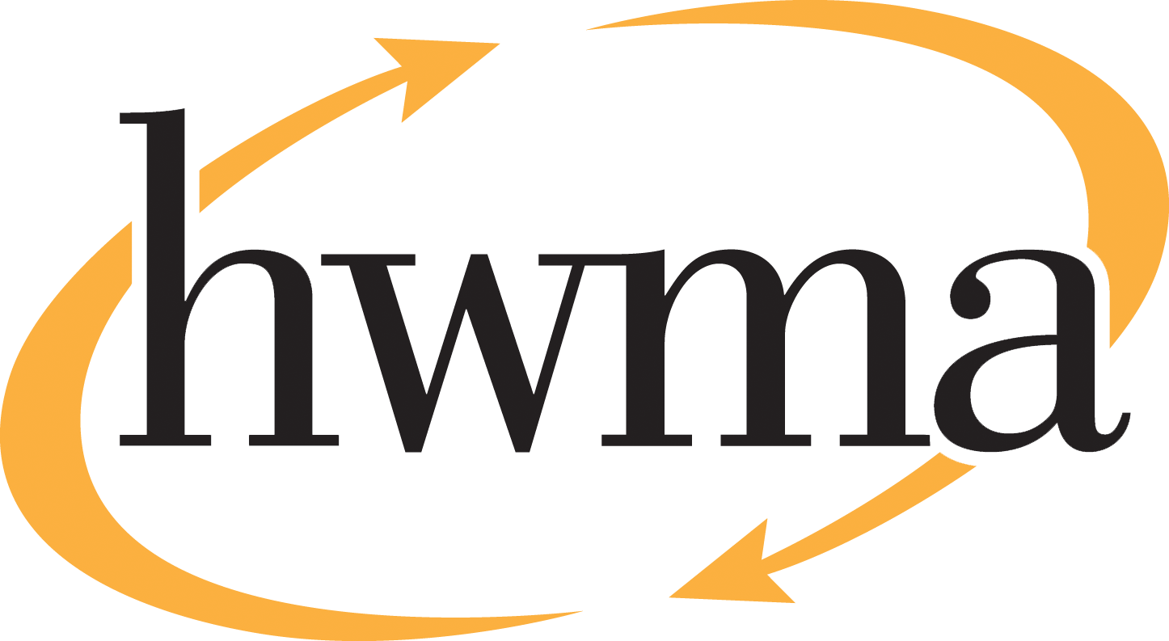
BOARD OF DIRECTORS
Stacy Atkins-Salazar, City of Arcata, Chair
Michelle Lewis-Lusso City of Blue Lake, Vice Chair
Leslie Castellano, City of Eureka
Randall Cady, City of Ferndale
Steve Madrone, County of Humboldt
Frank Wilson, City of Rio Dell
Minutes
Thursday, July 9, 2026, at 5:30 PM
Eureka City Council Chamber

Present: Stacy Atkins-Salazar, Michelle Lewis-Lusso, Leslie Castellano, Randall Cady, Frank Wilson.
Absent: Steve Madrone
Staff: Eric Keller-Heckman, Tony Heacock, Hilary Schwartz
Legal Counsel: Nancy Diamond

- Call to Order and Roll Call at 5:30 PM

Chairperson Atkins-Salazar called the meeting to order at 5:30 PM. A quorum was present and acting.

- Consent Calendar
  - Approve Minutes from the June 11, 2026, HWMA Board of Directors Meeting
  - Approve Minutes from the June 25, 2026, HWMA Board of Directors Special Meeting
  - Review and Approve Draft April 2026 Financial Reports
  - Receive and Approve Resolution 2027–03 “A Resolution of the Humboldt Waste Management Authority Authorizing the Authority to Enter into Regional Grant Agreements with the California Department of Resources, Recycling, and Recovery for Local Government Waste Tire Amnesty Grants During Fiscal Years 2027 through 2032.”
Chairperson Atkins-Salazar inquired if there were any requests to pull items from the Consent Calendar, and there were no requests.

Chairperson Atkins-Salazar opened the floor to public comment on the Consent Calendar, and no public comment was received.

Chairperson Atkins-Salazar closed the floor to public comment.

Motion: Director Castellano motioned, and Director Cady seconded, to approve items a) through d) of the Consent Calendar as delivered
Action: Approve the Motion as made by Director Castellano and seconded by Director Cady
Ayes: Unanimous
Noes: None
Absent: Director Madrone

- Oral and Written Communications

Chairperson Atkins-Salazar opened the floor to public comment, and no public comment was received.
Chairperson Atkins-Salazar closed the floor to public comment.
- Elect Authority Officers for Fiscal Year 2026–27

Executive Director Keller-Heckman advised the board that the HWMA Joint Powers Agreement requires the Authority to elect new board officers annually. Election periods run from July to June of the upcoming fiscal year. Board members discussed the required procedure when a board member’s term ends. General Counsel Diamond clarified that it is the individual, rather than the agency, that is being elected. Chairperson Atkins-Salazar expressed her willingness to step down or continue to serve as Chairperson. Director Lewis-Lusso indicated that she too was willing to step down or continue serving as Vice Chair. Board members expressed their support for current leadership to continue in their respective capacities.

Chairperson Atkins-Salazar opened the floor to public comment on the Authority Officers agenda item. No public comment was received.
Motion: Director Lewis-Lusso motioned, and Director Castellano seconded, to re-elect Chairperson Atkins-Salazar as Chairperson and Director Lewis-Lusso as Vice Chair of the HWMA Board of Directors for Fiscal Year 2026–27.
Action: Approve the Motion as made by Director Lewis-Lusso and seconded by Director Castellano
Ayes: Unanimous
Noes: None
Absent: Director Madrone
- Approve Board Calendar for Fiscal Year 2026–27

Executive Director Keller-Heckman explained that, in concert with officer elections, the Authority approves the Board of Directors calendar and schedule for the upcoming fiscal year. As in prior years, staff recommends there be no meeting scheduled in December, but unlike prior years, staff recommends holding an August meeting to seek board authorization for time-sensitive projects related to the Organics facility. Staff further recommends that the regularly scheduled monthly meetings on the second Thursday of each month and beginning at 5:30 pm remain unchanged for Fiscal Year 2026–27.

Chairperson Atkins-Salazar opened the floor to public comment on Board Calendar agenda item. No public comment was received.

Chairperson Atkins-Salazar closed the floor to public comment.
Motion: Director Cady motioned, and Director Wilson seconded, to approve the Board of Directors Calendar for Fiscal Year 2026–27 as presented.
Action: Approve the Motion as made by Director Cady and seconded by Director Wilson
Ayes: Unanimous
Noes: None
Absent: Director Madrone
- Review and Approve updates to HWMA Policy 3030 Reserve Policy

Director Schwartz presented comprehensive proposed revisions to HWMA Policy 3030 – Reserve Policy, developed in response to the recommendations made by the Authority’s auditor, Richardson & Company, LLP, in their Management Letter dated February 5, 2026. The auditors recommended that the Authority’s reserve policy be revised to include clear definitions of each reserve account and how its funding level is determined. Specifically, the auditors noted that the fund balance of the Operating Reserve did not match the funding level determined by Policy 3030, and the Long-Term Funding Reserve (i.e. Long-Term Organics Fund) was not included in Policy 3030.

Director Schwartz also presented information about Government Accounting Standards Board (GASB) Statement No. 54 (2009), which revised and standardized the recommended classification hierarchy for public agency reserve accounts. The revisions to Policy 3030 propose re-classifying the Authority’s reserve accounts from “undesignated,” which the auditors noted means undefined, to “assigned,” which aligns with the GASB 54 classification hierarchy. One exception is the Cummings Road Pledge of Revenue account, which was classified as Restricted, the highest level in the hierarchy, in the Authority’s Fiscal Year 2024–25 audited financial statements.

The revised policy includes the methodology for determining the funding level of the Operating Reserve and the intended uses of the Long-Term Organics Fund that were discussed and approved at the June regular meeting of this board. The revised policy also includes a minimum funding requirement for the unassigned Cash on Hand account of 30 days operating expenses. Finally, the revised policy includes an annual staff recommendation regarding the allocation of interest income and surplus revenue to unfunded pension liabilities.

Director Castellano inquired if the reserves that staff proposes be re-classified as Assigned should instead be classified as Committed. She was concerned that changes to reserve policies would not come before the board if the funds were classified as Assigned, and that they would if the funds were classified as Committed. Director Schwartz responded that the Authority’s reserve funds meet the GASB 54 criteria for Assigned, based on the governance policies currently in place. Executive Director Keller-Heckman explained that a federal grant that is prefunded would be an example of a Committed reserve, the uses of which are defined by an external entity and therefore outside board control.

Director Castellano requested that staff add language to the revised policy stating that, following the reclassification of reserve funds to Assigned, as defined in Attachment B of the board packet, staff will still be required to bring any changes to the reserve funds before the board for approval. Executive Director Keller-Heckman requested clarification on what Director Castellano meant by “changes.” Director Castellano responded that she was referring to changes in funding levels and the parameters that govern the funds. General Counsel Diamond suggested that Director Castellano direct staff to add the proposed language to the revised policy and bring it back to the board at the August meeting.

Chairperson Atkins-Salazar asked for confirmation that Policy 3030 was an existing HWMA policy and that only revisions were proposed. Executive Director Keller-Heckman confirmed that was the case, and that the proposed revisions placed more restrictions on the reserve funds than the current version of the policy. He further explained that the funding mechanism for the reserve accounts is almost always during the annual budget process. Funding levels for HWMA reserve accounts is either set by policy, such as the Personnel Stabilization Reserve policy which defines the funding level as $150,000; or during the annual budget process, as a line item embedded in the approved waste management fee structure, such as an annually calculated dollar amount per ton to fund approved capital improvement projects. However, staff can add additional protections into the language of the revised policy if so directed by the board.

Chairperson Atkins-Salazar inquired if other board members would prefer to entertain a motion rather than direct staff to incorporate the direction given at this meeting and bring the revised policy back before the board at the August meeting. No motion was made.
Chairperson Atkins-Salazar opened the floor to public comment on the Reserve Policy agenda item. No public comment was received.
Chairperson Atkins-Salazar closed the floor to public comment.

- Receive Presentation on Tire Recycling

Executive Director Keller-Heckman requested that the board direct staff to return at the August meeting with the presentation on tire recycling, as Director Morais was unable to attend the meeting to give the presentation.

Motion: Director Cady motioned, and Director Lewis-Lusso seconded, to direct staff to bring the tire recycling presentation back to the board at the August meeting.
Action: Approve the Motion as made by Director Cady and seconded by Director Lewis-Lusso
Ayes: Unanimous
Noes: None
Absent: Director Madrone
- Standing Item: Board Member Reports
Director Castellano reported that she and Chairperson Atkins-Salazar met with Executive Director Keller-Heckman to discuss strategic planning. They discussed facilitators and the intention to include member agency staff. She encouraged board members to begin reaching out to staff involved in waste management in their agencies who could contribute to the Authority’s strategic planning. Executive Director Keller-Heckman added that a tentative timeline for the project would be presented at the August meeting.

Chairperson Atkins-Salazar reported that she met with two individuals who were developing innovative new food waste composting techniques. There is potential that their methods could be used at scale in partnership with public agencies like the HWMA.

- Standing Item: Executive Director’s Report

Executive Director Keller-Heckman reported that the Authority had been awarded a new tire recycling grant that is now in effect. Individuals can bring up to nine (9) tires at a time to the Hawthorne Street Transfer Station and dispose of them at no charge. As there are some restrictions based on size and material, he encouraged members of the public to check the HWMA’s website or call the Main Office if they have questions about tire eligibility. The grant will be in effect until the funds are exhausted.

Chairperson Atkins-Salazar adjourned the meeting at 6:06 pm.

