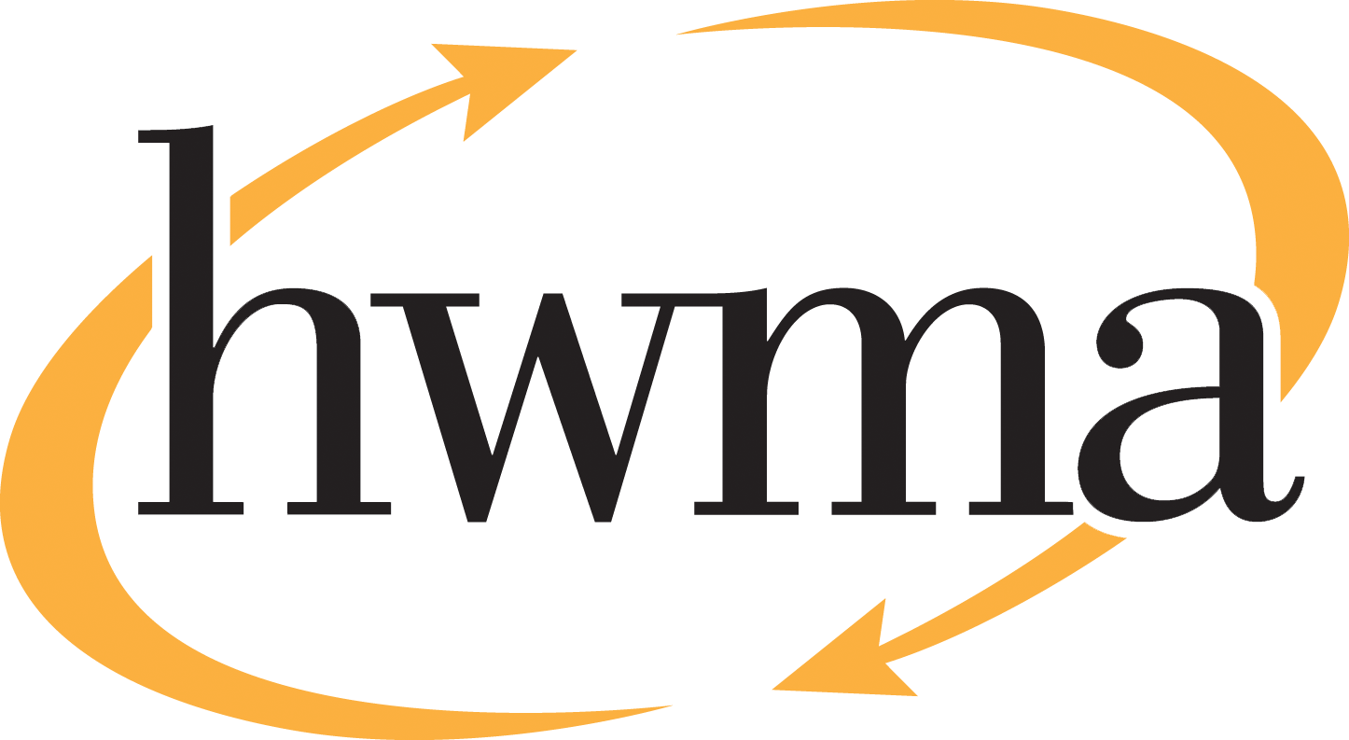
BOARD OF DIRECTORS
Meredith Matthews, City of Arcata, Chair
Michelle Lewis-Lusso City of Blue Lake, Vice Chair
Leslie Castellano, City of Eureka
Randall Cady, City of Ferndale
Steve Madrone, County of Humboldt
Frank Wilson, City of Rio Dell
Minutes
Thursday, November 13, 2025, at 5:30 PM
Eureka City Council Chamber

Present: Meredith Matthews, Elise Scafani (alternate), Leslie Castellano, Steve Madrone, Frank Wilson.
Absent: Randall Cady
Staff: Eric Keller-Heckman, Helder Morais, Hilary Schwartz
Legal Counsel: None

- Call to Order and Roll Call at 5:30 PM
Chairperson Matthews called the meeting was called to order at 5:30 PM. A quorum was present and acting.

- Consent Calendar
  - Approve Minutes from the October 9, 2025, HWMA Board of Directors Meeting.
  - Review and Approve Draft August 2025 Financial Reports
Chairperson Matthews inquired if there were any requests to pull items from the Consent Calendar, and there were no requests.

Chairperson Matthews opened the floor to public comment, and no public comment on the Consent Calendar was received.

Chairperson Matthews closed the floor to public comment.

Motion: Director Castellano motioned, and Director Madrone seconded, to approve items a) through b) of the Consent Calendar as delivered.
Action: Approve the Motion as made by Director Castellano and seconded by Director Madrone.
Ayes: Unanimous
Noes: None
Absent: Director Lewis-Lusso

- Oral and Written Communications

Chairperson Matthews opened the floor to public comment regarding items not on the agenda. No public comment was received.
Chairperson Matthews closed the floor to public comment.
- Approve Resolution 2026-07 and Update to Policy 4080 “Credit Cards” of the HWMA Policy Handbook

Executive Director Keller-Heckman advised the board that this item was a continuation in a series of updates to the HWMA Policy Handbook. HWMA Policy 4080 defines the Authority’s purchasing policies, and this particular policy relates to use of Authority credit cards. After consulting with Jamie Corsetti, CPA, who assists the HWMA with financial audit preparation, and Richardson & Company, CPAs, the HWMA’s new audit firm, staff recommends updating the policy language to reflect best practices regarding documentation of credit card purchases. Staff recommends updating the required documentation for credit card purchases to include the following information: account number, vendor name, date of purchase, invoice number, description of items purchased, total purchase amount, and payment method.

Director Castellano requested clarification that the policy update impacted purchase documentation only, which Executive Director Keller-Heckman confirmed. Chairperson Matthews thanked staff for their efforts to thoroughly update the Policy Handbook.

Chairperson Matthews opened the floor to public comment. No public comment was received.

Chairperson Matthews closed the floor to public comment.
Motion: Director Castellano motioned, and Director Madrone seconded, to approve Resolution 2026-07, updating Policy 4080 “Credit Cards” of the HWMA Policy Handbook.
Action: Approve the Motion as made by Director Castellano and seconded by Director Madrone.
Ayes: Unanimous
Noes: None
Absent: Director Lewis-Lusso
- Receive Update on 457 Match
Executive Director Keller-Heckman began by reviewing that at their October 13th, 2025, regular meeting, the board had directed staff to return at this meeting with specific policy recommendations regarding a potential 457 plan match. Executive Director Keller-Heckman briefly reviewed the historical changes that have occurred with the CalPERS defined benefit retirement plans, including the prohibition on employer “pick-up” of employee contributions, and how that has affected HWMA employees. Executive Director Keller-Heckman further reviewed the deferred compensation retirement plans currently available to all HWMA staff regardless of their CalPERS classification.

Executive Director Keller-Heckman described the board’s recent direction to conduct a poll of current employees, including participation rates and staff interested in participating in a 457 plan, and to determine what other local agencies offer a similar benefit. Executive Director Keller-Heckman presented a chart of staff distribution by years of service and division. Approximately 60% of HWMA staff has been with the Authority for 10 years or less, while about 25% have been with the Authority for 20 years or more, with a large gap in between. The internal poll regarding plan participation and interest in a 457 match revealed that enrollment increased after the board’s discussion at the October meeting, with 37% or 11 staff members now participating and an additional 6 staff members expressing interest in participating. The 457 plan representative met with staff onsite to ensure that all questions were accurately addressed. Finally, staff identified eight local agencies that offer a similar benefit to HWMA’s proposed 457 match, although staff noted a diverse variety of methodologies used to calculate those benefits, including some achieved through collective bargaining.

Executive Director Keller-Heckman then reviewed the match contribution calculations at 3% or 5% of simple wages, and the total fiscal impact the contributions would have on the Authority budget if all staff members participated and made maximum contributions. Executive Director Keller-Heckman advised that with a current participation rate of 11, it is unlikely that the introduction of a match would lead to 100% participation with maximum contributions. If the board choses to move forward, staff will return with proposed funding levels and ideas staff has discussed internally regarding the best way to budget for these potential expenditures. Staff recommends the board provide direction on the options presented. If the board choses to move forward with one of the options presented, staff recommends the board to direct staff to return no later than January with draft policy language.

Director Madrone inquired as to the Authority’s turnover rate, noting that improved employee benefits increase longevity and reduce the costs associated with onboarding and training new employees. Executive Director Keller-Heckman advised that turnover has decreased since the pandemic and the closure of the Eureka Recycling Center. However, several positions have been frozen, making the turnover rate in recent years difficult to compare to prior years. Director Madrone asked if the proposed 457 match would increase longevity, and Executive Director Keller-Heckman replied that the proposed match would benefit employees across the board.

Director Castellano inquired about the recent history of cost-of-living adjustments. Executive Director Keller-Heckman explained the current methodology for these adjustments, based on the West Region Worker Consumer Price Index, capped at a maximum of 5% annually. Director Castellano inquired if there was a problem with attrition, and Executive Director Keller-Heckman reiterated that while there is not significant problem with attrition, frozen positions have made retention comparisons difficult. Director Castellano asked if this proposed policy was the result of a collective bargaining agreement, and Executive Director Keller-Heckman responded that it was not. Director Castellano inquired about the years of service of the staff members who were interested in participating in the plan if there was an employer match. Director Schwartz responded that two of the interested staff members were in the 10 years and under group, whereas the other two were in the 20 years and over group. Director Schwartz also indicated that the 457 plan was an effective recruitment tool among applicants who are coming from other local agencies.

Chairperson Matthews affirmed the value of a 457 match but inquired if the expenditure would require the Authority to raise rates. Director Schwartz recommended that the board to review the presentation slide showing the total potential impact of the proposed match on the tip fee. Chairperson Matthews inquired if that potential impact would be in addition to recent rate increases, and Executive Director Keller-Heckman confirmed that the cost of a match would be additive to current rates due to the way the Authority budgets for costs and collects fees. Chairperson Matthews expressed hesitation due to other public utility increases that are planned for her jurisdiction. Director Madrone commented that both the cost savings of increased retention and the cost burden of increased turnover are not always visible in the current budget cycle. Executive Director Keller-Heckman reminded the board how valuable experienced employees are, particularly given that they operate heavy equipment that is extremely expensive to repair if damaged by inexperienced operators. Director Madrone added that inexperience can also lead to workplace injuries, which can be even more costly for the Authority.

Chairperson Matthews opened the floor to public comment. No public comment was received.

Chairperson Matthews closed the floor to public comment.

Director Castellano expressed support for staff and retention efforts but stated that recent rate increases affecting her constituents made it impossible for her to support any resolutions that would lead to additional increases to the tip fee in the current economic climate. She indicated that she would be willing to revisit the proposed match in the future or if it did not impact rates, given the recent history of significant cost of living increases for HWMA staff. Chairperson Matthews indicated that she was inclined to agree with Director Castellano, and suggested the item be brought back before the board again in the future.

Director Madrone reiterated his opinion that the proposed match would also yield costs savings and inquired if there was a way to absorb the cost in the short-term, identify the final enrollment levels, and then determine if a rate increase is necessary to continue providing the benefit. Executive Director Keller-Heckman responded that staff would recommend implementing the proposed match at the beginning of the next fiscal year, and that the Authority has an Employee Benefits reserve fund that could be utilized in the short-term to absorb the increased costs. Executive Director Keller-Heckman expressed hesitation about implementing a benefit with the risk of having to pull it back due to lack of available funds. Additionally, as with all costs, replenishing reserves would be a net additive to the tip fee.

Director Madrone commented that if the Authority was unionized like many of the other local agencies, this benefit would likely be required by a collective bargaining agreement. He continued that while he supported the proposed match, he did not want to make a motion that lacked broader support from his fellow board members. However, he requested an update on greenwaste and organics recycling and suggested that the proposed match be revisited in the context of the new services the Authority will be rolling out in the coming fiscal year. Executive Director Keller-Heckman responded that an update on organics will be coming in January, including an update on the feasibility study RFP. Chairperson Matthews confirmed that the board would not be moving forward with the proposed match at this time. Director Scafani inquired as to how staff arrived at the two proposed match levels of 3% and 5%, and if a 2% match was an option. Executive Director Keller-Heckman responded that the match level, if any, would be determined by board discretion, but that 3% and 5% were two common mid-range match levels among the agencies that staff contacted, although the full range was between 1.5% and 8%. Director Madrone thanked staff for conducting the polling and asked for clarification if the Authority was matching current staff contributions. Executive Director Keller-Heckman responded that the Authority is not currently matching staff contributions so all projected costs of a match would be new, even if the level of enrollment did not increase. Director Wilson requested clarification about the graphs presented and indicated that he thought that it would be beneficial to revisit the topic in January with updated information about staff’s expectations for the next fiscal year and budget.

- Standing Item: Board Member Reports

The Directors had no further reports.

- Standing Item: Executive Director’s Report

Executive Director Keller-Heckman reported the Organics Feasibility Study RFP had been circulated and staff expected to have a chosen proposer to recommend at the board meeting in January. Additionally, Director Morais will present a look inside another operational activity in January to keep the board informed about HWMA daily operations.

Chairperson Matthews adjourned the meeting to at 6:08 pm.

