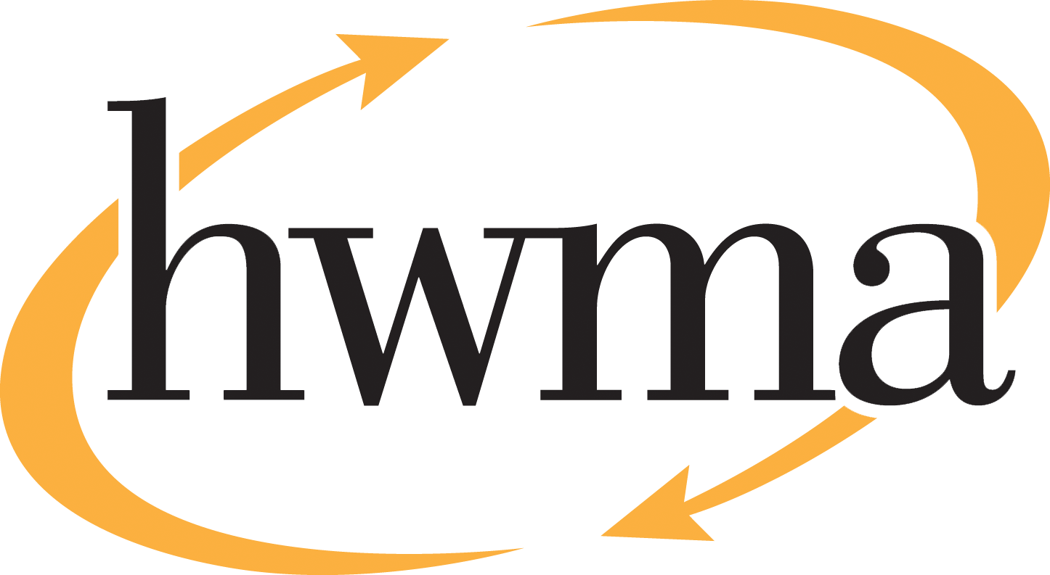
BOARD OF DIRECTORS
Stacy Atkins-Salazar, City of Arcata, Chair
Michelle Lewis-Lusso City of Blue Lake, Vice Chair
Leslie Castellano, City of Eureka
Randall Cady, City of Ferndale
Steve Madrone, County of Humboldt
Frank Wilson, City of Rio Dell
Minutes
Thursday, April 9, 2026, at 5:30 PM
Eureka City Council Chamber

Present: Stacy Atkins-Salazar, Elise Scafani (alternate), Leslie Castellano, Randall Cady, Frank Wilson.
Absent: Steve Madrone
Staff: Eric Keller-Heckman, Tony Heacock, Helder Morais, Hilary Schwartz
Legal Counsel: Nancy Diamond

- Call to Order and Roll Call at 5:30 PM

Chairperson Atkins-Salazar called the meeting to order at 5:30 PM. A quorum was present and acting.

- Consent Calendar
  - Approve Minutes from the March 12, 2026, HWMA Board of Directors Meeting
  - Review and Approve Draft January 2026 Financial Reports
  - Approve Sourcewell Program for purchase of a Landfill Mower in Lieu of Competitive Bid Process
  - Approve California Multiple Award Schedule Pricing Program for the Purchase of Caterpillar 920 Loader for Organics
Chairperson Atkins-Salazar inquired if there were any requests to pull items from the Consent Calendar, and there were no requests.

Chairperson Atkins-Salazar opened the floor to public comment on the Consent Calendar, and no public comment on the Consent Calendar was received.

Chairperson Atkins-Salazar closed the floor to public comment.

Motion: Director Cady motioned, and Director Wilson seconded, to approve items a) through d) of the Consent Calendar as delivered
Action: Approve the Motion as made by Director Cady and seconded by Director Wilson
Ayes: Unanimous
Noes: None
Absent: Director Madrone

- Oral and Written Communications

Chairperson Atkins-Salazar opened the floor to public comment regarding items not on the agenda. No public comment was received.
Chairperson Atkins-Salazar closed the floor to public comment.
- Receive Presentation on Draft Fiscal Year 2026–27 Budget

Executive Director Keller-Heckman presented the board with an overview of the Authority’s draft Fiscal Year 2026–27 budget. The budget timeline begins with the initial presentation on April 9, 2026, after which the draft budget is provided to the HWMA Executive Advisory Committee for comment. Staff anticipates the board will adopt the Fiscal Year 2026–27 budget and Waste Management Fee resolution at its regular meeting on May 14, 2026. Following adoption, staff will circulate the adopted resolution and fee schedule to member agencies and franchise haulers the week of May 18, 2026. The new fee schedule will be implemented at the start of Fiscal Year 2026–27 on July 1, 2026.

The Authority’s budget assumptions encompass projected revenues, projected expenditures, member agency tonnage, and grant programs, all of which impact, and cause adjustments to, the waste management fee structure. Other key elements of the budget include the Authority reserves, personnel compensation, and the Capital Improvement Plan. The final discussion item is the upcoming Organics fee structure and how that operation will impact the fee structure going forward.

- Revenue assumptions are based on a projected 83,000 tons of member agency solid waste and approved grant funding. Total projected revenue is $17,085,527, a slight decrease over the prior fiscal year.
- Expenditure assumptions are based on CPI adjustments for applicable contracts, a proposed COLA of 2.7% for all staff, and implementation of all identified capital projects. Total projected expenditures are $17,085,527, a slight decrease over the prior fiscal year.
- Backhauls have continue to decline and are projected at a rate of 10% for FY 26–27. Staff worked closely with transportation partners to project fuel price increases amid multiple uncertainties in this economic sector.
- No timber revenues have been projected for the last few fiscal years. If a timber harvest is scheduled in FY 26–27, staff will return to the board to request direction on how to allocate the revenue.
- The Solid Wate portion of the Waste Management Fee structure is composed of three main components:
  - Countywide Program Fee, which houses County pass-throughs and programs such as AB 939, the local enforcement agency fees, and illegal dumping and clean up funds. These fees are charged on all tons generated within member agency boundaries.
  - HWMA Base Fee, which funds all other programs and divisions outside of Solid Waste, Household Hazardous Waste, and Organics divisions. These fees are charged on all tons delivered by member agencies to transfers stations within Humboldt County.
  - Facility Fee, which houses the transportation and disposal costs of member agency waste to Dry Creek Landfill, direct and indirect operational costs of handling that solid waste, and necessary reserve funding requirements. These fees are charged on all tons delivered to the Hawthorne Street Transfer Station only.
- Summary of proposed rate adjustments (per ton), subject to finalization:
  - Self-Haul: $215.81 (3.51% increase)
  - Franchise: $193.48 (3.23% increase)
  - Recology Eel River Satellite Fee: $156.75 (1.59% decrease)
  - Humboldt Sanitation Satellite Fee: $153.91 (2% decrease)
  - Greenwaste: $161.47 (2% increase)
  - Recyclable Materials: To be determined following staff review
- Three of the Authority’s four distinct reserve funds are fully funded for FY 26–27, with the Capital Improvement Fund requiring an increase of $881,676 to meet funding requirements. Staff is analyzing the Authority’s reserve policy and funding levels and will return to the board with recommendations as needed prior to the FY 27–28 budget cycle.
- The methodology used to propose the 2.7% Cost-of-Living adjustment for Authority staff was approved by this board in FY 24–25. The FY 26–27 draft budget also proposes unfreezing all currently frozen Materials Diversion Technician (MDT) positions prior to the start of the Organics operation.
- The FY 26–27 Capital Improvement Plan proposes three new projects:
  - 2029:04: Solid Waste Scales 1 & 2 Replacement
  - 2033.02: Paving Trailer Staging Area
  - 2033.03: Landfill Roof Replacement & Solar Panels
- The HWMA Organics Processing Facility is expected to come online in October 2026, representing a significant shift in the way the Authority handles revenues and expenditures related to greenwaste. The Organics fee line item is no longer present in the HWMA Base Fees for Solid Waste, as these costs will be included in a brand-new facility fee structure that will replace the current greenwaste fee when the Organics processing facility opens.

Director Castellano inquired about the Organics line item in the Base Fees in the FY 25–26 budged. Executive Director Keller-Heckman responded that that line item was around $6 per ton and utilized to prepare the future Organics facility in concert with grant funds. Director Castellano inquired if the costs associated with a potential property purchase had been included in the draft budget, and Executive Director Keller-Heckman replied that they had not. Director Wilson inquired about the location of the Organics facility. Executive Director Keller-Heckman responded that the Organics acceptance facility would be located at the Hawthorne Street Transfer Station in the former Eureka Recycling Center building, and that organic material would then be transported to the Cold Creek compost facility in Mendocino County for processing. Director Castellano requested an update on the Organics facility preparations. Executive Director Keller-Heckman responded that he was confident the facility would be ready for the anticipated October start date, and that staff would be returning to the board in September with a new Organics facility fee to support the costs associated with the new operation. In the interim period, facility preparations will rely on grant funding.

Chairperson Atkins-Salazar inquired about the declining backhaul rate. Executive Director Keller-Heckman explained that historically, the Authority enjoyed backhauling rates of up to 60%, with trucks returning from Dry Creek Landfill in Oregon with loads of wood chips bound for the Scotia co-generation plant or loads of soil bound for garden supply retailers. Both activities have severely declined over the past 5-10 years. Despite the challenges, the Authority’s transportation partners are constantly looking for backhauls to bolster their bottom line and reduce costs for the Authority’s rate payers. Chairperson Atkins-Salazar inquired about how the costs for the four unfrozen MDT positions would be covered if Organics revenue was not being collected yet. Executive Director Keller-Heckman explained that the unfrozen MDT positions would not be filled until immediately prior to the start of the Organics operation, and that the costs associated with those positions would be incorporated into the new Organics facility fee structure. Chairperson Atkins-Salazar inquired if staff was requesting any specific direction from the board to finalize the draft budget. Director Keller-Heckman replied that at this time they were not.

Chairperson Atkins-Salazar opened the floor to public comment on the draft budget agenda item. No public comment was received.

Chairperson Atkins-Salazar closed the floor to public comment.

- Strategic Vision Planning

Executive Director Keller-Heckman reviewed that at the February 2026 regular meeting, the HWMA Board directed staff to meet with an ad hoc committee to develop the scope and next steps of future strategic vision planning. The ad hoc committee met in March and discussed the broad intent and overall direction of the strategic vision planning, including stakeholders, project timelines, activities, potential jurisdictional priorities, and the recommendation to use a local facilitator due to staff’s limited bandwidth. The committee identified participation, engagement, and clear, measurable goals as important aspects of the process. Staff believe they have sufficient direction to initiate this planning process and welcome any additional input the board may have at this time.

Chairperson Atkins-Salazar expressed that the strategic vision planning was a great opportunity and noted the enthusiasm of staff and colleagues. Director Castellano provided a recap of the committee meeting and emphasized the importance of participation by jurisdiction staff and key stakeholders. She noted the significance of new projects on the horizon, such as a compost facility, as well as potential new projects ton consider, such as a reuse center. Director Castellano requested feedback from the board members that did not participate in the committee as to how they would like to be included or updated on the committee’s progress. Chairperson Atkins-Salazar confirmed that the committee would bring any potential decisions to the full board for discussion and direction.

Chairperson Atkins-Salazar opened the floor to public comment on the strategic vision planning agenda item. No public comment was received.

Chairperson Atkins-Salazar closed the floor to public comment.
Motion: Director Castellano motioned, and Director Cady seconded, to authorize the Executive Director to initiate strategic vision planning and continue working with the ad hoc committee that has been established for that purpose.
Action: Approve the Motion as made by Director Castellano and seconded by Director Cady
Ayes: Unanimous
Noes: None
Absent: Director Madrone

- Standing Item: Board Member Reports

Director Castellano reported that the 7th Annual Spring Garden Giveaway event, featuring free compost from Recology, would be held on Saturday, April 18, 2026, from 9:00 am to noon at the Recology facility located at 555 Vance Avenue in Samoa. Director Scafani reported that the City of Blue Lake would be working with CalFire to utilize a greenwaste incinerator at their power plant site to process greenwaste collected at the City’s May community greenwaste event. Stacy Atkins-Salazar thanked HWMA staff for hosting the ad hoc committee and for their hard work and enthusiasm.

- Standing Item: Executive Director’s Report

The Executive Director had no further reports.

- Closed session: It is the intention of the Board of Directors to meet in closed session for two items:

  - Closed session pursuant to Government Code 54956.8 Real Property to consider the potential price and terms of purchase of APN 405-081-036.

  - Public Employment Evaluation – Executive Director pursuant to Government Code Section 54957.

- Report Out of Closed Session: No report.

Chairperson Atkins-Salazar adjourned the Closed Session at 6:50 pm.

