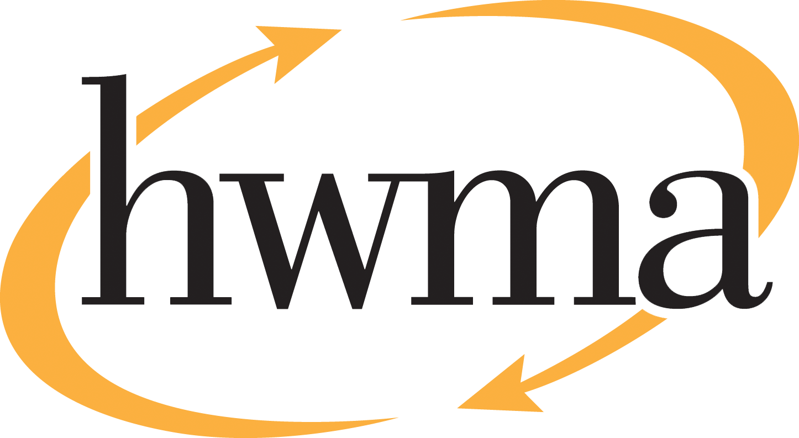
BOARD OF DIRECTORS
Stacy Atkins-Salazar, City of Arcata, Chair
Michelle Lewis-Lusso City of Blue Lake, Vice Chair
Leslie Castellano, City of Eureka
Randall Cady, City of Ferndale
Steve Madrone, County of Humboldt
Frank Wilson, City of Rio Dell
Minutes
Thursday, February 12, 2026, at 5:30 PM
Eureka City Council Chamber

Present: Stacy Atkins-Salazar, Elise Scafani (alternate for Michelle Lewis-Lusso), Leslie Castellano, Randall Cady.
Absent: Michelle Lewis-Lusso, Steve Madrone, Frank Wilson
Staff: Eric Keller-Heckman, Tony Heacock, Helder Morais, Hilary Schwartz
Legal Counsel: Nancy Diamond

- Call to Order and Roll Call at 5:30 PM

Chairperson Atkins-Salazar called the meeting to order at 5:30 PM. A quorum was present and acting.

- Consent Calendar
  - Approve Minutes from the January 8, 2026, HWMA Board of Directors Meeting
  - Review and Approve Draft November 2025 Financial Reports
Chairperson Atkins-Salazar inquired if there were any requests to pull items from the Consent Calendar, and there were no requests.

Chairperson Atkins-Salazar opened the floor to public comment, and no public comment on the Consent Calendar was received.

Chairperson Atkins-Salazar closed the floor to public comment.

Motion: Director Cady motioned, and Director Castellano seconded, to approve items a) through b) of the Consent Calendar as delivered
Action: Approve the Motion as made by Director Cady and seconded by Director Castellano
Ayes: Unanimous
Noes: None
Absent: Directors Lewis-Lusso, Wilson and Madrone

- Oral and Written Communications

Chairperson Atkins-Salazar opened the floor to public comment regarding items not on the agenda. No public comment was received.
Chairperson Atkins-Salazar closed the floor to public comment.
- Receive Auditor’s Report for Fiscal Year 2024-2025
Director Schwartz informed the board that the annual financial audit is a tool by which the board and the general public may measure the fiscal health of the Authority. The HWMA Board approved a request for proposals (RFP) for financial audit services in November 2024, and the contract was awarded to the successful proposer, Richardson & Company, LLP, in April 2025. Following the close of Fiscal Year 2024-2025, the auditors completed a thorough examination of all aspects of the Authority’s financial systems and provided recommendations in their independent audit report. Staff has implemented or partially implemented many of the recommendations and will work closely with the auditors to ensure continuing compliance with Governmental Accounting Standards Board (GASB) standards in all financial reporting.
Ingrid Sheipline of Richardson & Company, LLP, presented a detailed overview of her firm’s reporting on the Authority’s financial statements. Miss Sheipline’s presentation covered the auditor’s opinion of the financial statements, the internal control and compliance report, the required governance letter, and a letter to management with recommendations for improvement. The auditors issued an unmodified or clean opinion, which means they determined that the Authority’s financial statements were fairly presented in accordance with required accounting principles.

Miss Sheipline provided some points of discussion regarding the Authority’s financial statements. The first discussion item was the Authority’s negative unrestricted Net Position, which is related to two long-term liabilities: the Cummings Road Landfill estimated post-closure liability of approximately $10 million, described in Note D to the financial statements; and the Pension Plan liability of approximately $2 million, described in Note F. There were no significant changes in actuarial assumptions in Fiscal Year 2024-2025. With about $5 million in assets, the Authority’s financial position is good, but accounting regulations require the Authority to accrue and disclose the long-term liabilities, which results in negative equity on the balance sheet.

The Statement of Revenues and Expenses reflects net income of $881,000 added to reserves, which is comparable to net income in Fiscal Year 2023-2024. Note E to the financial statements describes the Authority’s reserves, which total approximately $3.2 million, including a pledge of revenue for landfill post-closure costs that has been designated as restricted. Note I to the financial statements details a restatement that reduced net position by $159,278 for sick leave accrual expected to be used, which is now required per GASB Statement 103. An additional restatement was made to correct an error in an asset disposal transaction.

The Internal Control and Compliance Report noted no internal control weaknesses and reflects the auditor’s opinion that the Authority complied with applicable laws and regulations related to the financial statements. The Governance Letter focuses on information the auditors are legally required to disclose, such as areas where management judgement and/or estimates were relied upon in the financial statements. The auditors encountered no difficulties in performing the audit and no unusual accounting practices. A total of 3 adjustments were made by the auditors.

The Management Letter outlines recommendations for improvement in financial accounting, but not material weakness. The auditors provided six recommendations:

- Changes to the capitalization policy
- Develop an anti-fraud/whistleblower policy
- Develop a risk assessment process
- Revisions to the reserve policy
- Date bank transfers as of transaction date
- Payroll to be reviewed by Executive Director
Director Castellano requested clarification of terminology related to the reserve policy. Miss Sheipline responded that the auditors recommended that the Authority better define the intent of each reserve fund, and if the reserve level is a function of operating revenue. Chairperson Atkins-Salazar thanked staff for their contribution to the audit process.
Chairperson Atkins-Salazar opened the floor to public comment. No public comment was received.

Chairperson Atkins-Salazar closed the floor to public comment.

- Receive Presentation on Carpet Recycling
Director Morais gave a presentation to the board on carpet recycling. Over 340 million pounds of carpet end up in California landfills each year that could be recycled into new products. Old carpet can be recycled into new carpet fiber, tiles, and underlayment, as well as a range of products used in industries including automotive, transportation, construction, and home and garden. Director Morais explained that the HWMA joined the Carpet America Recovery Effort (CARE) when the program first started in 2012. When customers come over the HWMA’s inbound scale with carpet, they are directed to a dedicated 28-foot box trailer that is staged at the Transfer Station. The customer offloads their carpet, which must be reasonably clean, cut in to 4 to 6-foot lengths, and rolled backing side facing out, and then stacks the rolls in the box trailer from front to back. When the customer returns to the outbound scale, they inform the scale attendant that they recycled carpet and they are charged just $2 for up to 400 pounds of carpet, significantly less than the solid waste tip fee. Since the program’s inception, the HWMA has diverted over 2.3 million pounds of carpet from the landfill.

Director Scafani inquired if most of the carpet came from professional installers. Director Morais responded that the carpet comes from both professional installers and homeowners. Director Castellano expressed her appreciation for the program and inquired about end uses for recycled carpet. Director Morais described a variety of products that are manufactured from recycled carpet. Chairperson Atkins-Salazar inquired about how much carpet was included for the fee of $2. Director Morais indicated that 400 pounds of carpet typically fills the back of a pick-up truck, and that a homeowner who is replacing carpet in one room will generally weigh in under the 400 pound limit. Chairperson Atkins-Salazar expressed appreciation for the information about both mattress and carpet recycling at HWMA that she can provide to her constituents. Director Cady requested clarification about the acceptable length of carpet sections, and Director Morais replied that the acceptable length is 4 to 6 feet, which makes the rolls easier for customers to stack in the trailer.
Chairperson Atkins-Salazar opened the floor to public comment. No public comment was received.

Chairperson Atkins-Salazar closed the floor to public comment.

- Receive Update on Organics Processing Feasibility Study

Executive Director Keller-Heckman provided an update on the Organics Processing Feasibility Study following staff’s review of the proposal that was submitted. He began by reviewing the timeline of the study and RFP process that began in November 2024. Following two unsuccessful circulations, the RFP was re-released in October 2025 and one proposal was received. Following staff review, the proposal was deemed nonresponsive due to missing required documents. Meetings were held with jurisdiction staff who had earmarked grant funds for this study. The majority of jurisdiction staff felt that grant funds should be reallocated to other SB 1383 purposes until such time as organics collections and acceptance is underway in Humboldt County.

Director Castellano reflected on the long path to SB 1383 compliance for local jurisdictions. She inquired why the feasibility study RFP had received so few responses and how the board could move the process forward. Executive Director Keller-Heckman responded that the scope of the original RFP was too broad, particularly combined with the lack of collection and processing data available at the time. He acknowledged that despite great efforts on the part of staff, jurisdictions, and the franchise haulers, the rural nature of our area is an obstacle for consulting firms already engaged in larger projects. Once in-county organics collection is underway, there will be more data to guide potential proposers. Executive Director Keller-Heckman emphasized that staff has not given up on in-county processing or feasibility.

Director Scafani asked about the date collection will commence, and Executive Director Keller-Heckman indicated that the precise date has not been determined at this time. Director Scafani inquired if there was currently in-county greenwaste processing, and Executive Director Keller-Heckman replied that there was not. Staff seeks to develop solutions for all organic material processing that will encompass both greenwaste and food waste. Director Castellano asked if collection might commence at different times in different jurisdictions. Executive Director Keller-Heckman responded that while exact commencement dates may vary, there will be a coordinated plan to roll out services across the jurisdictions in concert with franchise agreement and facility updates. Chairperson Atkins-Salazar acknowledged the broad community support for local organics processing, despite the challenges of the roll out.

Chairperson Atkins-Salazar opened the floor to public comment. Praj White, Northpoint Consulting, provided public comment on the proposal his firm submitted for the feasibility study. Mr. White took responsibility for the omission of the anti-collusion statement that was required for a complete submission and expressed his enthusiasm to complete the study with his team of consultants if the contract was awarded to his firm. Evan Edgar, Edgar & Associates, provided public comment on the strength of the local team involved in the RFP submission and concurred with Executive Director Keller-Heckman’s assessment that the larger consulting firms were too busy for this project.

Chairperson Atkins-Salazar closed the floor to public comment.

Director Castellano inquired if Northpoint Consulting provided the required anti-collusion statement, would their proposal be deemed responsive. General Counsel Diamond responded that the proposal had been rejected and the request was closed out. The board could direct staff to re-release the RFP and review a new round of proposals if they so choose. Director Castellano expressed hope that the board could engage in a more detailed conversation about the study. Executive Director Keller-Heckman indicated that jurisdiction staff who have earmarked grant funds will benefit from some direction from the board at this time.

Chairperson Atkins-Salazar agreed that staff needed direction regarding grant funding. Director Scafani inquired that, if the RFP was re-released, would the Authority move forward with a responsive proposal. Executive Director Keller-Heckman indicated that the Authority would support that decision but also seek confirmation from jurisdiction staff regarding use of grant funds. Chairperson Atkins-Salazar asked if the determination of nonresponsiveness had been subject to a board vote, and Executive Director Keller-Heckman responded it had not. General Counsel Diamond indicated that it was a board level decision to deem a proposal nonresponsive. Executive Director Keller-Heckman responded that historically, RFP responsiveness has been determined at the staff level.

Director Cady inquired if grant funds were not used now, would they be available in the future. Executive Director Keller-Heckman responded that the funds currently earmarked for the feasibility study would be reallocated to other projects if the contract is not awarded now. Director Scafani suggested that the feasibility study be brought back at the next board meeting for further consideration. Executive Director Keller-Heckman affirmed that he would be meeting with jurisdiction staff in the next week to gather their input regarding the proposal and best use of available grant funds.

Motion: Director Scafani motioned, and Director Cady seconded, that the Organics Feasibility Study proposal be brought before the board for further evaluation at the next meeting
Action: Approve the Motion as made by Director Scafani and seconded by Director Cady.
Ayes: Directors Cady, Scafani, and Castellano
Noes: Chairperson Atkins-Salazar
Absent: Directors Lewis-Lusso, Madrone and Wilson

- Discuss Strategic Vision Planning

Executive Director Keller-Heckman described how the board had requested that Strategic Vision Planning be agendized for discussion. Staff had requested that the board provide direction on the intended timing and time frame of the planning and which jurisdiction staff and/or consultants should participate. Chairperson Atkins-Salazar commented that three regular board members were absent. Director Castellano indicated that she would like to complete the project with a consultant and jurisdiction staff before the end of her term on the Eureka City Council. Director Scafani concurred that she would prefer to start on strategic vision planning now. Chairperson Atkins-Salazar noted there was general consensus among board members to proceed.

Chairperson Atkins-Salazar opened the floor to public comment. No public comment was received.
Chairperson Atkins-Salazar closed the floor to public comment.

General Counsel Diamond inquired if the board would like to make a motion to form a subcommittee. The board members discussed interest and availability in the coming month and concluded that a three-person subcommittee of Chairperson Atkins-Salazar and Directors Cady and Castellano should be proposed.
Motion: Director Castellano motioned, and Director Scafani seconded, for Chairperson Atkins-Salazar and Directors Cady and Castellano to form a subcommittee for Strategic Vision Planning.
Action: Approve the Motion as made by Director Castellano and seconded by Director Scafani
Ayes: Unanimous
Noes: None
Absent: Directors Lewis-Lusso, Madrone and Wilson

- Standing Item: Board Member Reports

The Directors had no further reports.

- Standing Item: Executive Director’s Report

Executive Director Keller-Heckman reported that CalRecycle would be issuing the Authority a new Notice to Proceed for the Organics ORG7 grant. The new grant agreement has been executed, and the Authority is now authorized to proceed with the facility upgrades necessary to accept organic material at the Hawthorne Street Transfer Station. Additionally, CalRecycle approved the Authority’s request for an extension of the grant term through April 2027.

- Closed session

It is the intention of this Board of Directors to meet in closed session for one item, pursuant to Government Code 54956.8 Real Property, to consider the potential price and terms of purchase of APN 405-081-036.

- Report Out of Closed Session: No report.

Chairperson Atkins-Salazar adjourned the Closed Session at 7:14 pm.

